**Technical Solution Approach**

Contents

1 Introduction 2

1.1 About this document 2

1.1.1 Purpose & Scope of the document 2

2 Component Design 2

2.1 Component Design Diagram 2

2.1.1 Overall Workflow 2

2.1.2 Low level Design 2

3 Technology & Frameworks to be used 3

4 Solution Approach 3

# Introduction

## About this document

### Purpose & Scope of the document

The purpose of the component specification is to systematically record the understanding of component design and the expected usage. This document also include the design elements and the workflow wherever possible.

# Component Design

## Component Design Diagram

This section should explain the details about how the component design is and why we the component is designed in the specific way. This section should showcase the sequence diagram, class diagram and the flow chart for the overall functionality.

### Overall Workflow

E.g. Sample diagram below is for the encryption.

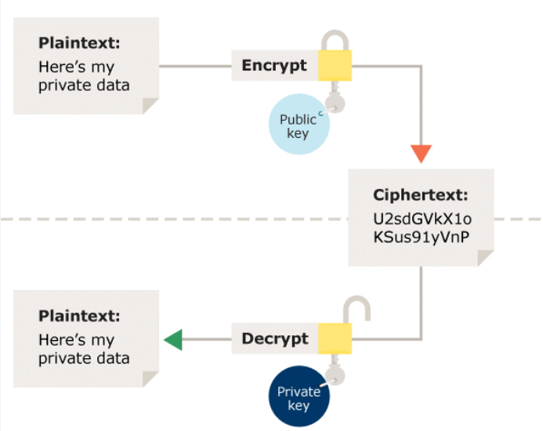

Sample Sequence diagram for the student login as below:

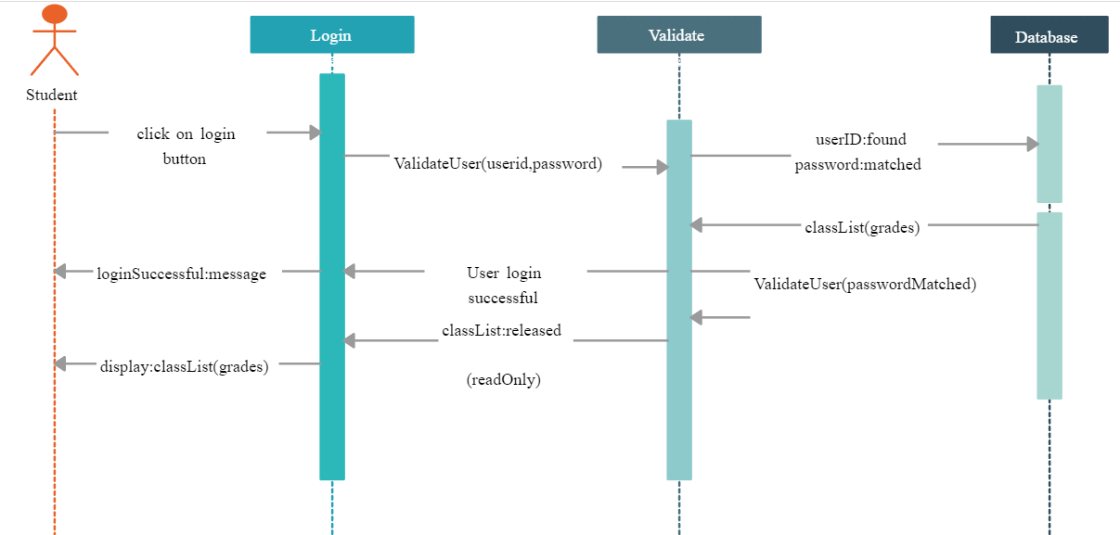

### Low level Design

This section should explain the details end to end workflow with the method level details. Below is the sample diagram just for reference.

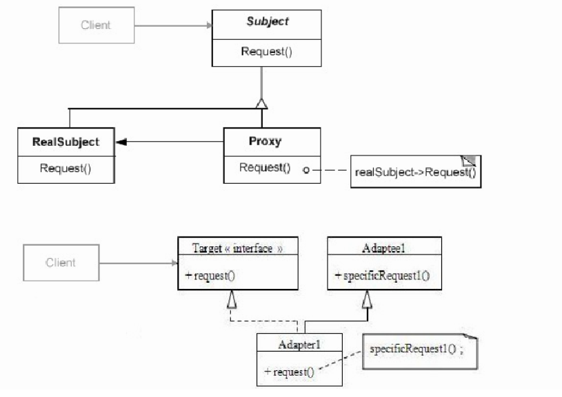

# Technology & Frameworks to be used

This section should list down the details on technology and framework used for development as well as for testing.

E.g.

1. Angular JS 13
2. .NET framework 6.0
3. Mongo DB 6.0

# Solution Approach

This section should provide a detailed view of how the functionality and responsibilities of the system were partitioned and then assigned to subsystems or components. If any specific pattern or practice used then that can be highlighted here.

Below is the sample solution approach:

1. As per the above design diagram we can think of creating a UI processing engine.
2. (If there are any software pattern which fits for this component creation purpose then mention the details for the same)
3. The UI component will be having the responsibility of ( details of the responsibilities of the component.
4. The UI component will be utilizing the information stored in the JSON format for the html tags.
5. This component will further call the service (details of the interacting component functionality)
6. This component will be created as a self dependent module (module in angular and jar or dll with Java and .net)
7. We will create a sample test application and we will invoke the newly created component.
8. The imported component will be added to page x and page y with the below set of 2 different configurations.(mention the details on different configurations or different ways of binding)
9. Below are the test scenarios for the component ( details about test scenario 1 ,2,3,4 and the expected behavior for those test scenarios)